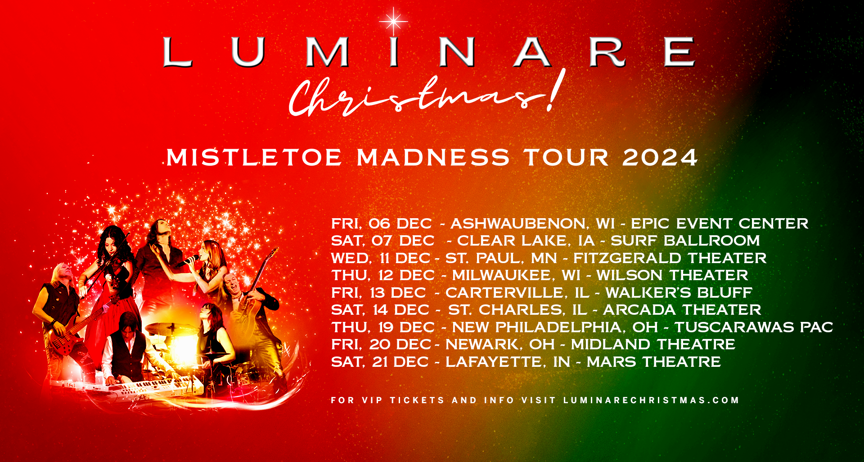

**LUMINARE CHRISTMAS! ANNOUNCE**

**2024 MISTLETOE MADNESS TOUR**

LUMINARE CHRISTMAS! brings you a holiday concert event that will take you on a magically visual and powerfully musical journey. Drawing from his many years as keyboardist for Dennis DeYoung (STYX) and lead keyboardist for Mannheim Steamroller, John Blasucci and **LUMINARE CHRISTMAS!** have created a new, high energy holiday tradition. Experience a Christmas rock concert that will take you on a powerful visual and musical journey. Re-imaginings of Christmas classics as well as brand new original music will leave you feeling the joy and majesty of the most wonderful time of the year!

LUMINARE CHRISTMAS! will be ringing in the holiday season with nine shows this December throughout the US. Fans can expect, “a high energy symphonic rock concert filled with beautiful visuals and cinematic magic telling evocative stories of the season”. Tickets & VIP packages available and on sale week of September 9.

**DATE CITY VENUE**

12/6 Ashwaubenon, WI EPIC Event Center

12/7 Clear Lake, IA Surf Ballroom

12/11 St. Paul, MN Fitzgerald Theater

12/12 Milwaukee, WI Wilson Theater

12/13 Carterville, IL Walker’s Bluff Casino

12/14 St. Charles, IL Arcada Theater

12/19 New Philadelphia, OH Tuscarawas Performing Arts Center

12/20 Newark, OH Midland Theatre

12/21 Lafayette, IN Mars Theatre

Find LUMINARE CHRISTMAS! Online: [luminarechristmas.com](http://www.luminarechristmas.com/)

For Press Inquiries pls contact: [info@bladesentertainment.com](mailto:info@bladesentertainment.com?subject=Luminare%20Christmas!)